Sample website text

Promote the free peer review course on your institution’s website using the sample text below.

Learn the foundations of good peer review

A free online course on peer review from Nature Masterclasses
Focus on Peer Review (https://masterclasses.nature.com/online-course-on-peer-review/16507836) is a free-to-access course, aimed at researchers who are new to peer review or wish to refresh their skills.
Course details:
- Access: Free-to-access when you register on Nature Masterclasses
- Course duration: 3-4 hours
- Instructors: Nature Research journal editors and experienced researchers from Imperial College London and King’s College London
- Certificates: Free certificates-of-completion
- Provided by: Nature Masterclasses, a training service from Nature Research, part of Springer Nature
Course contents:
- Module 1: Your Role as Peer Reviewer
- Module 2: The Peer Review Report
- Module 3: Ethics in Peer Review
- Module 4: Variations and Innovations in Peer Review
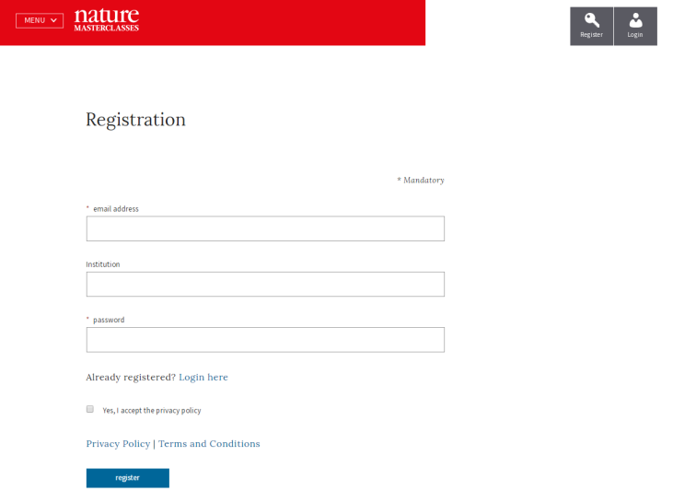

Start your access today!
Register on the Nature Masterclasses website and gain instant free access to the Focus on Peer Review course: https://masterclasses.nature.com/register

